Care Oversight

Screen 1:

Start with first screen of Acuity

If I click anywhere on Stella Smith it will outline in red.

If I click on “bulls eye” icon for Stella (insights) it will outline in red

If it wont work to have an outline within an outline, then you can just outline Stella Smith’s name and the icon.

Example below:

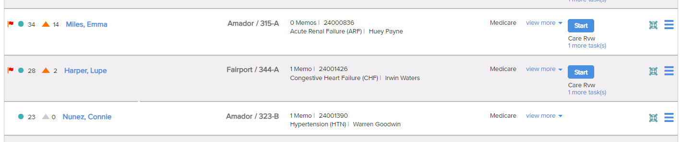

Screen 2:

Show Insights Screen for Stella Smith

We will need to do quite a it of work on this screen to make it “work” for Stella Smith

Insert same pic that we used in PCC

Change name

Change Dr name to match

Change Primary Dx to what was used in first slot of wheel

Current protocol: make say Care Review Q.D.

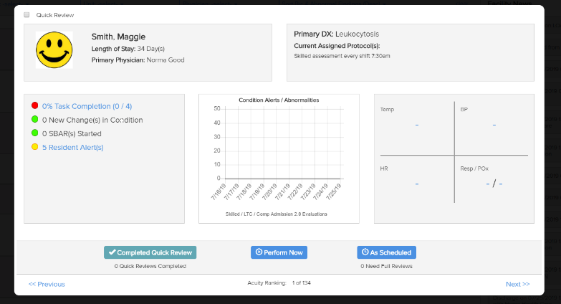

First box:

0% task completed (0/1) – red bubble

Keep new changes in condition. We will need to change this number based on whatever we end up documenting for her.

Remove SBAR started.

Remove resident alert(s)

Center:

Will replace with graph based on first assessment we enter (TBD)

Vitals – Show vitals from assessment (TBD)

Screen 3: Back to page 1 again.

Click to highlight around “Sort By”

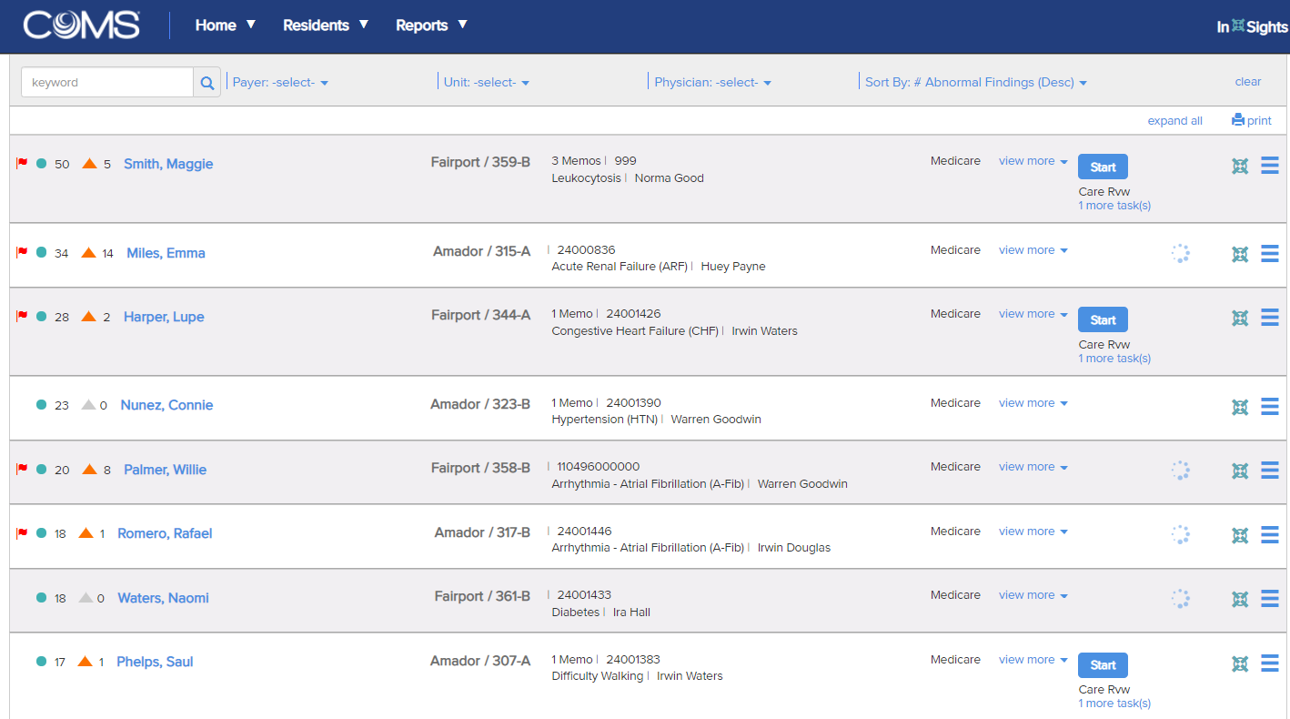

Click to highlight top Resident in list

(screenshot is just for visual, use the screen you have already built in Acuity).

Screen 4-?: TBD – I need to touch base with you re: Resident name we used/ clinical situation etc.